1. INTRODUCTION
   1. Overview

A business card typically includes the giver’s name,

Company or business affiliation (usually with a logo )

And contact information such as street addresses.

* 1. Purpose

Make you look professional ,build trust in customers,

And set your small business apart from others.

1. Problem Definition & Designing Thinking
   1. Empathy map

Paste the empathy map screenshot

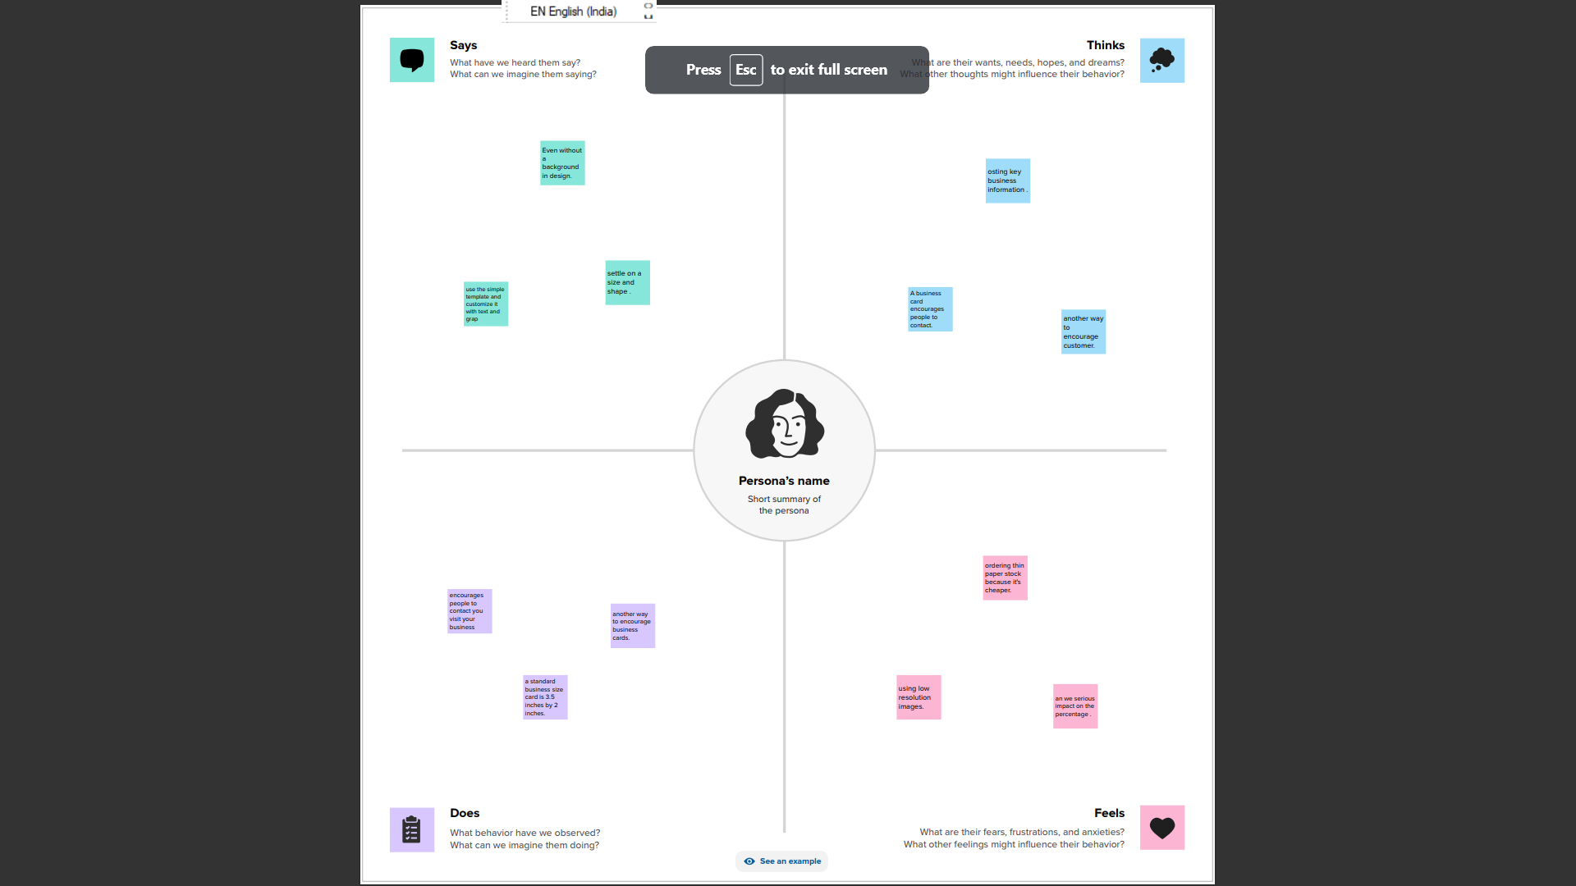

* 1. Ideation & Brainstorming map

Paste the ideation & brainstorming map screenshot.

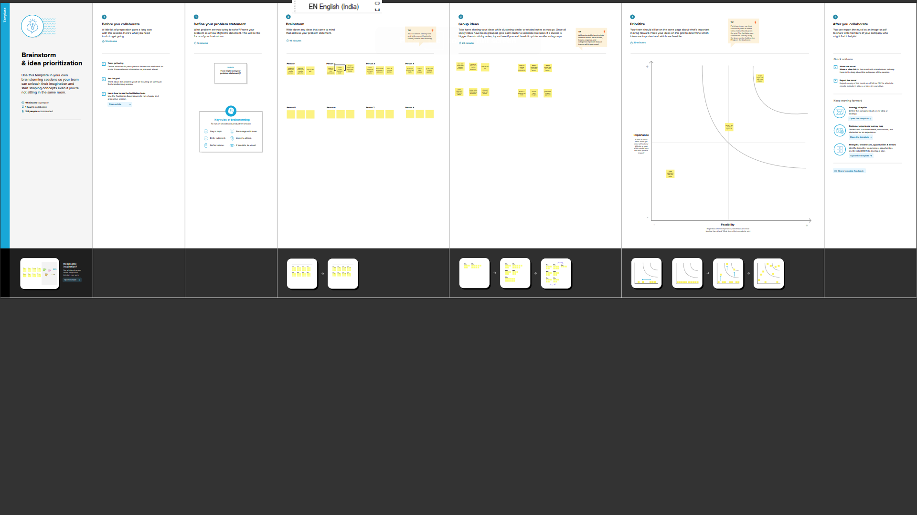

1. RESULT

Final flindings (output) of the project along with screenshot

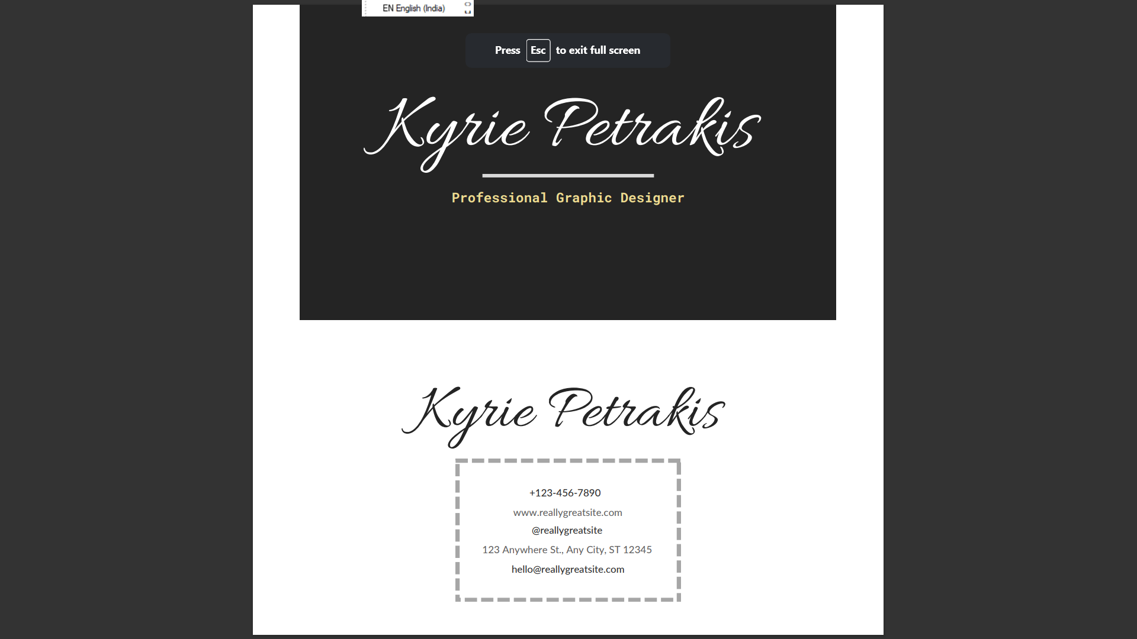

1. ADVANTAGES & DISADVANTAGES

1.Affordableadvertisement

2.people won’t forget your email.

3.cost – effective and budget -friendly.

4.easy integration with CRM and contact

Management system.

5 APPLICATIONS

Encourages people to contact you,visit your business

(online or in realife ) and learn more about you.

1. CONCLUSION

Digital business cards offer a great way to save time and

Money while also helping to protect the environment.